EX.NO:08 | DONATION PLATFORM
DATE:

1.Aim :
To develop a Donation Platform web application using React that allows users to create campaigns, donate money, track progress, and view donor details dynamically.
2.Procedure :
Step 1 : Create a React app and import useState.
Step 2 : Create form inputs to add campaign details.
Step 3 : Add new campaigns to state using a function.
Step 4 : Display campaigns using .map().
Step 5 : Implement donation and update amount raised.
Step 6 :Show progress bar and donor details.
Step 7 :Add delete option to remove campaigns.
3.PROGRAM SOURCE CODE :
import React, { useState } from "react";

export default function App() {
const [campaigns, setCampaigns] = useState([]);
const [newCampaign, setNewCampaign] = useState({ title: "", description: "", goal: "" });

const handleCreate = () => {
if (!newCampaign.title || !newCampaign.goal) return;
const newData = {
id: Date.now(),
title: newCampaign.title,
description: newCampaign.description,
goal: Number(newCampaign.goal),
raised: 0,
donors: []
};
setCampaigns([...campaigns, newData]);
setNewCampaign({ title: "", description: "", goal: "" });
};

const handleDonate = (id, amount, name) => {
if (!amount || !name) return;
setCampaigns(campaigns.map(c => {
if (c.id === id) {
return {
...c,
raised: c.raised + Number(amount),
donors: [...c.donors, { name, amount, date: new Date().toLocaleString() }]
};
}
return c;
}));
};

const handleDelete = (id) => {
setCampaigns(campaigns.filter(c => c.id !== id));
};

return (
<div className="p-6 bg-gray-100 min-h-screen">
<h1 className="text-3xl font-bold mb-6 text-center">💰 Donation Platform</h1>

{/* Create Campaign */}
<div className="bg-white p-4 rounded shadow mb-6">
<h2 className="text-xl mb-3">Create Campaign</h2>
<input
placeholder="Title"
value={newCampaign.title}
onChange={e => setNewCampaign({ ...newCampaign, title: e.target.value })}
className="border p-2 mr-2 mb-2 w-full"
/>
<textarea
placeholder="Description"
value={newCampaign.description}
onChange={e => setNewCampaign({ ...newCampaign, description: e.target.value })}
className="border p-2 mr-2 mb-2 w-full"
/>
<input
placeholder="Goal Amount"
type="number"
value={newCampaign.goal}
onChange={e => setNewCampaign({ ...newCampaign, goal: e.target.value })}
className="border p-2 mr-2 mb-2 w-full"
/>
<button onClick={handleCreate} className="bg-blue-600 text-white px-4 py-2 rounded w-full">
Create Campaign
</button>
</div>

{/* Campaign List */}
{campaigns.length === 0 && <p className="text-center">No campaigns yet.</p>}

{campaigns.map(campaign => (
<Campaign key={campaign.id} campaign={campaign} onDonate={handleDonate} onDelete={handleDelete} />
))}
</div>
);
}
function Campaign({ campaign, onDonate, onDelete }) {
const [amount, setAmount] = useState("");
const [name, setName] = useState("");

const progress = Math.min((campaign.raised / campaign.goal) * 100, 100);
return (
<div className="bg-white p-4 mb-6 rounded shadow">
<div className="flex justify-between items-center">
<h3 className="text-xl font-semibold">{campaign.title}</h3>
<button onClick={() => onDelete(campaign.id)} className="text-red-500">Delete</button>
</div>
<p className="text-gray-600">{campaign.description}</p>
<p className="mt-2">Goal: ₹{campaign.goal}</p>
<p>Raised: ₹{campaign.raised}</p>

{/* Progress Bar */}
<div className="w-full bg-gray-200 h-4 my-3 rounded">
<div
className="bg-green-500 h-4 rounded"
style={{ width: `${progress}%` }}
></div>
</div>
<p className="text-sm">{progress.toFixed(1)}% completed</p>

{/* Donate Section */}
<div className="mt-4">
<input
placeholder="Your Name"
value={name}
onChange={e => setName(e.target.value)}
className="border p-2 mr-2 mb-2"
/>
<input
placeholder="Amount"
type="number"
value={amount}
onChange={e => setAmount(e.target.value)}
className="border p-2 mr-2 mb-2"
/>
<button
onClick={() => {
onDonate(campaign.id, amount, name);
setAmount("");
setName("");
}}
className="bg-green-600 text-white px-4 py-2 rounded"
> Donate
</button>
</div>
{/* Donor List */}
<div className="mt-4">
<h4 className="font-semibold">Donors:</h4>
{campaign.donors.length === 0 && <p>No donations yet.</p>}
{campaign.donors.map((d, i) => (
<div key={i} className="text-sm border-b py-1">
{d.name} donated ₹{d.amount} <span className="text-gray-500">({d.date})</span>
</div>
))}
</div>
</div>
);
}
4.SAMPLE INPUT AND OUTPUT :
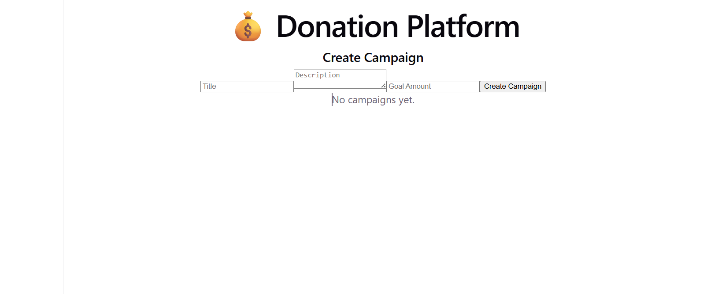
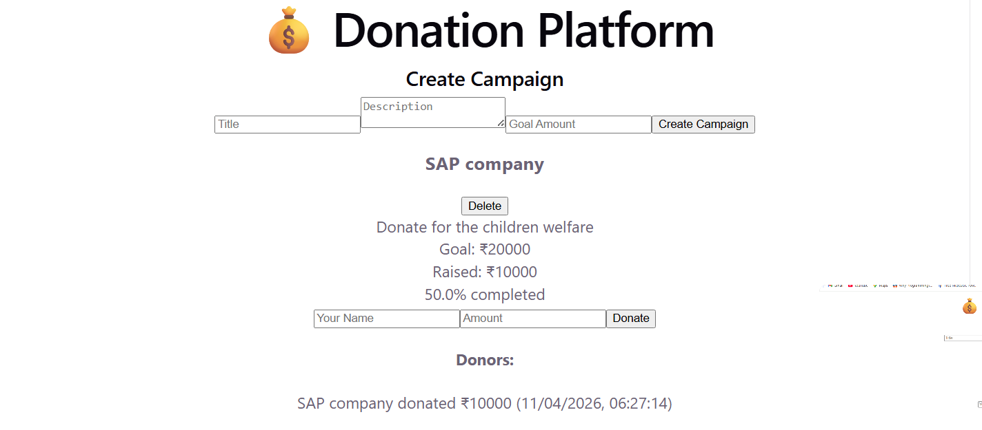

5.RESULT :
The application allows users to create campaigns, donate money, and view progress.It shows campaign details, donation status, and donor information dynamically.

